Title of your Abstract
(Times New Roman, Bold, CAPITAL, Font Size-12)

Authors Name: Presenting Author¹, Author A², Author B^{1,*}
(Times New Roman, Regular, Font Size-12)
¹University/Institute/organization, City, Country (Times New Roman, Italic, Left Aligned, Font Size-10)
²University/Institute/organization, City, Country (Times New Roman, Italic, Left Aligned, Font Size-10)
*Corresponding author:author@institute.ac.in (Times New Roman, Regular, Left Aligned, Font Size-10)

Abstract: (Full abstract not exceeding 250 words in Times New Roman, Regular, Justified, Font Size-12; The abstract should not exceed one page, including all the components) An abstract is a single paragraph, without indentation, a compendious summary of a paper's substance, including research question, background, purpose, methodology, results, and conclusion in 175 to 250 words [1]. An abstract is a single paragraph, without indentation, a compendious summary of a paper's substance, including research question, background, purpose, methodology, results, and conclusion in 175 to 250 words [1]. An abstract is a single paragraph, without indentation, a compendious summary of a paper's substance, including research question, background, purpose, methodology, results, and conclusion in 175 to 250 words [1]. An abstract is a single paragraph, without indentation, a compendious summary of a paper's substance, including research question, background, purpose, methodology, results, and conclusion in 175 to 250 words [1]. An abstract is a single paragraph, without indentation, a compendious summary of a paper's substance, including research question, background, purpose, methodology, results, and conclusion in 175 to 250 words [1]. An abstract is a single paragraph, without indentation, a compendious summary of a paper's substance, including research question, background, purpose, methodology, results, and conclusion in 175 to 250 words [1]. An abstract is a single paragraph, without indentation, a compendious summary of a paper's substance, including research question, background, purpose, methodology, results, and conclusion in 175 to 250 words [1]

Keywords: Writing, Abstract Template, IEMDST-2026, Second Edition, Goa (Minimum 4 and maximum 6, Times New Roman, Regular, Justified, Font size-12)

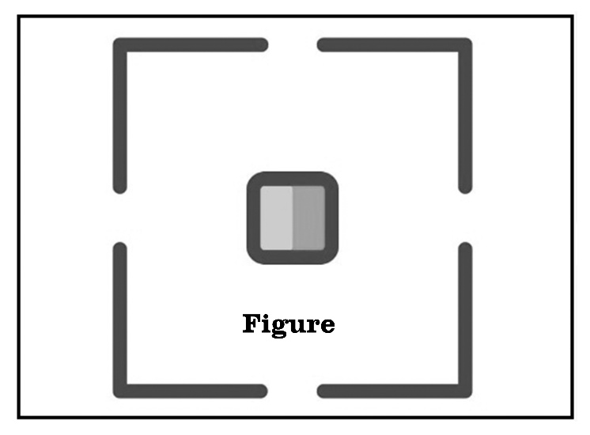
Figure Caption: Description of image not exceed two lines (Times New Roman, Regular, Center Aligned, Font size-12)

References: (Times New Roman, Regular, Justified, Font Size-10)
[1] M. Zakotnik, A.J. Williams, G. Martinek, I.R. Harris, J. Alloys Compd. 450 (2008) 23-30.

